**eSuperbill Gap Analysis**

Providers or clinical staff generate the eSuperbill, and once it's signed by a provider, our RCM team begins the process of creating charges from it. We generate eSuperbill using workflows from provider notes as well as through a method for quick eSuperbill creation. Currently, several gaps in our eSuperbill module need addressing.

**Limitations/Gaps:**

The limited fields on eSuperbill to add all required information while creating the eSuperbill.

**Enhancement of Practice-Specific Fields:**Implement a feature that allows practice-specific additional fields in the eSuperbill, enabling users to add any necessary information that providers may need to provide during the billing process. Currently, the billing team creates a Provider List (PL) and requests information from providers which they can input directly into the eSuperbill.

**Proposed Additional Fields:**   
To ensure comprehensive data collection, the following fields should be added: Copay, Advances, Date Range for Date of Service (DOS), Admission and Discharge Date, CLIA number, Referral details, and PAN (Permanent Account Number).

**Enhanced Accessibility:**   
Make the patient name and insurance details clickable hyperlinks on the eSuperbill to facilitate quick access to detailed information.

**Selection of Billing Provider:**   
Allow practice staff and rendering providers to select the billing provider directly on the eSuperbill page to streamline the billing process.

**Comment Segregation:**   
Distinguish between internal and billing instructions in comments added by client users. By segregating these, specific rules can be applied to billing comments, and only relevant comments can be forwarded with the claim to the insurance provider.

**Management of NDC Details:**   
Introduce effective and termination dates for National Drug Codes (NDC) used in procedures to ensure only active and valid NDCs are displayed on the eSuperbill. This update is crucial as the current lack of NDC date tracking leads to billing rejections due to outdated or incorrect NDC usage.

**Client Instructions for Billing Management:** Clients often use the comments section or banner notes on the eSuperbill to issue specific billing instructions to the RCM team. These instructions might include directives not to bill the patient or insurance under certain circumstances. For example, they might request that patient responsibilities such as copayments, coinsurance, and deductibles be waived or written off for specific patients on certain service dates.

**E&M Calculator Placement:** Currently, the E&M Calculator is integrated into the eSuperbill, but a more appropriate placement would be within the provider or progress notes. This adjustment aligns with practices observed among our competitors and has also been suggested by our client services feedback. Moving the calculator to the provider or progress notes would enable providers to use it more effectively during their documentation process.

**Provider to eSuperbill:**

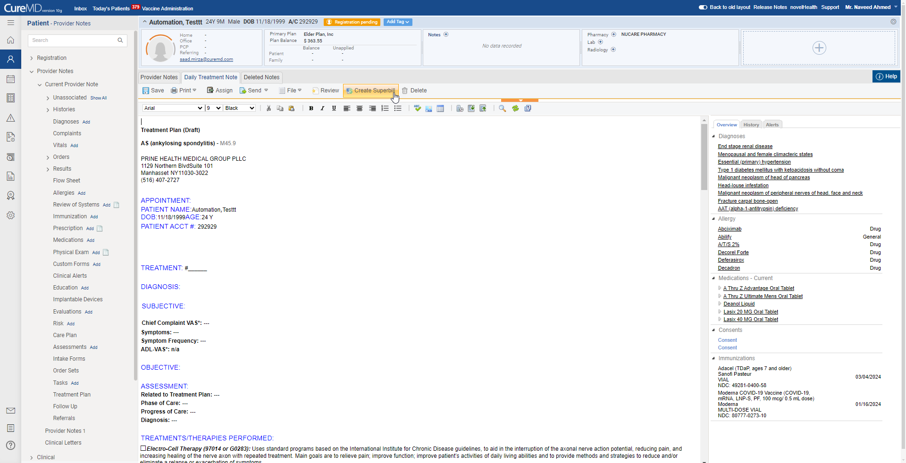

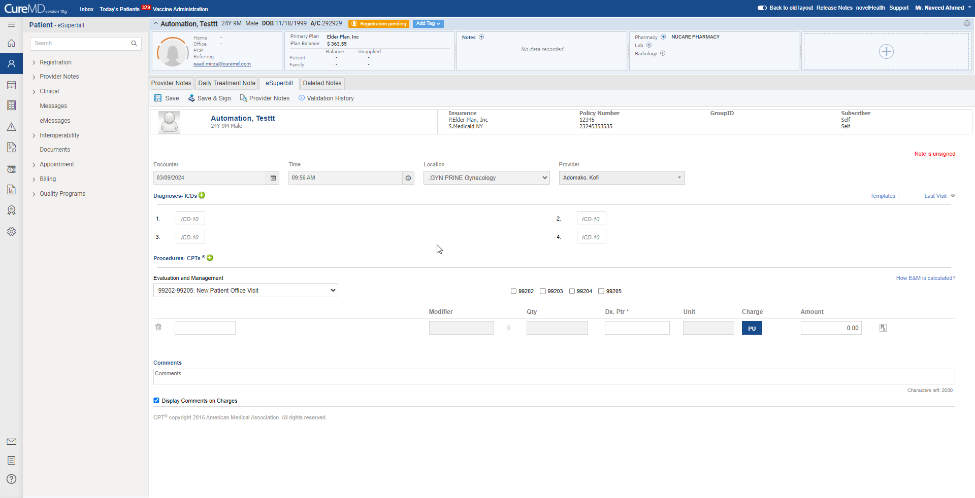

**Quick eSuperbill**

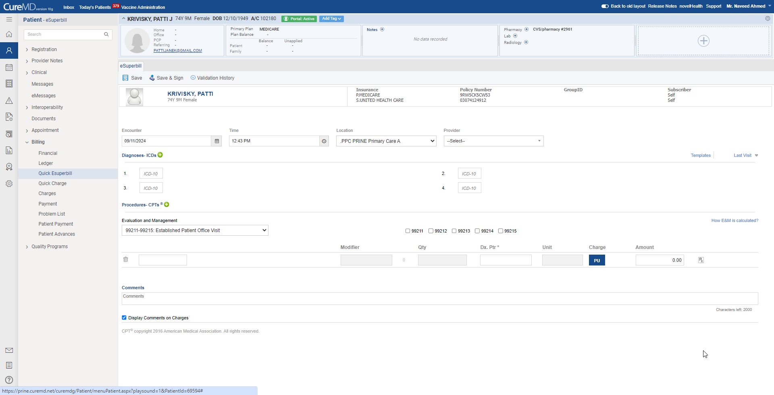

Competitor Analysis

E-Super Bill

# **eCW**

## Summary

In eCW, the process of creating a Superbill begins with locking the Progress Note, which signifies that it has been signed. Once locked, the Super Bill can be created. Codes from the Progress Note automatically populate, and additional ICD codes can be added via a search function. After all necessary details are filled in, the Superbill can be saved, completing the Super Bill.

For viewing Superbills, set the claim status to “Encounter Without Claims” in the Claims Listing page. Here, Locked encounters are identified by a padlock icon.

## Create Superbill

From the Schedular, the user navigates to the Progress Note.

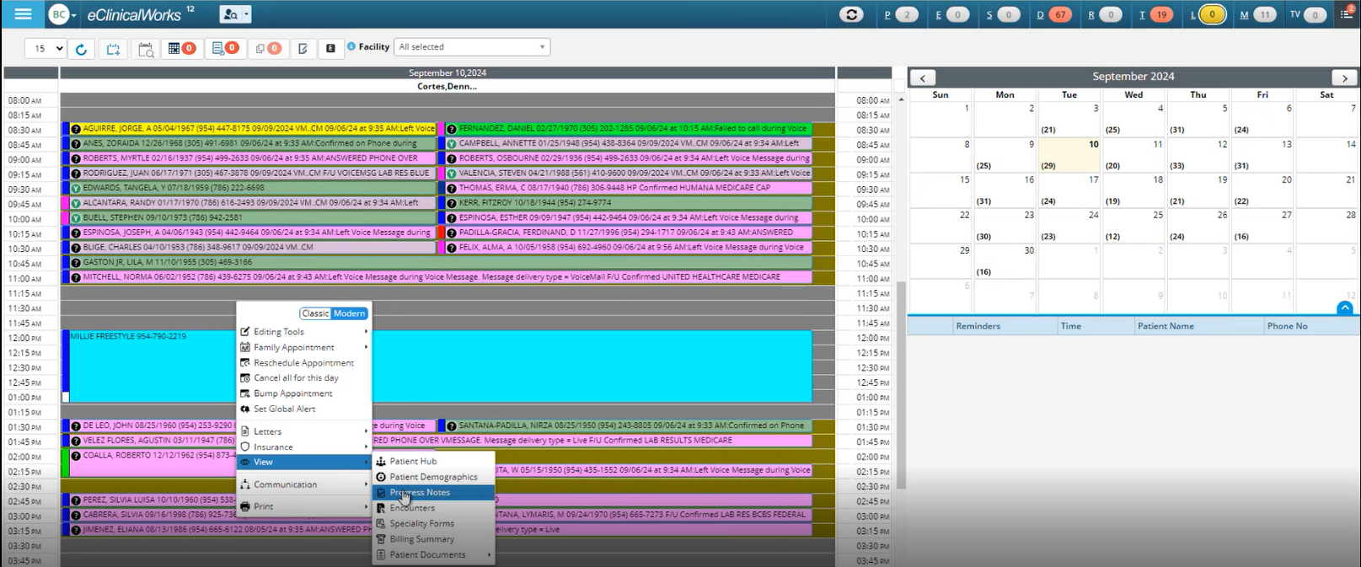

From the Progress note, the user locks it. Lock means signed.

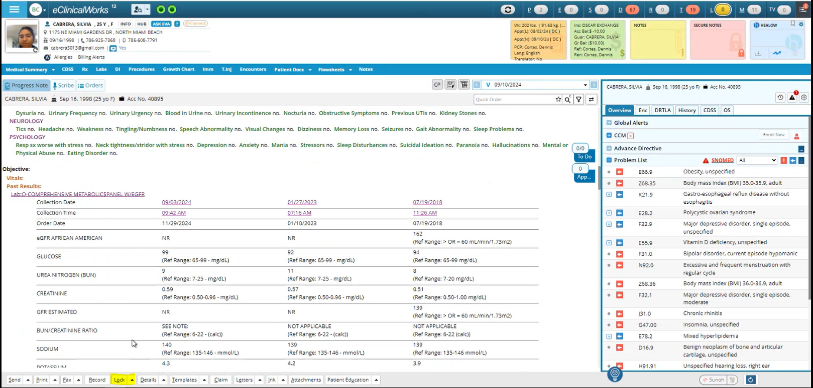

After locking the Progress Note, the user can create a Super Bill, as shown below

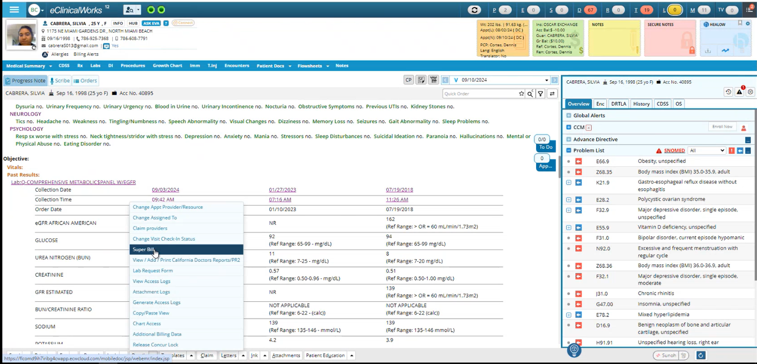

(From here, the user can directly navigate from Progress Note to the charge page.)

On the left of the Super Bill, the Codes are populated from the Progress Note. The user can add ICD codes to the bill through the search.

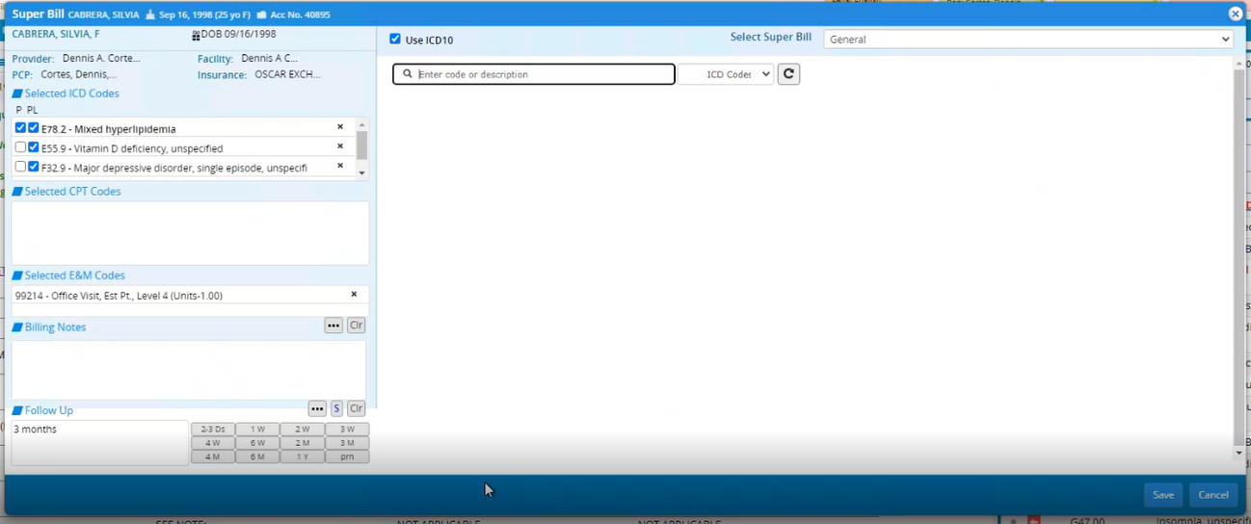

On-clicking the 3 dots, the frequently used notes are displayed. The user is facilitated through these billing keywords to fill notes quickly.

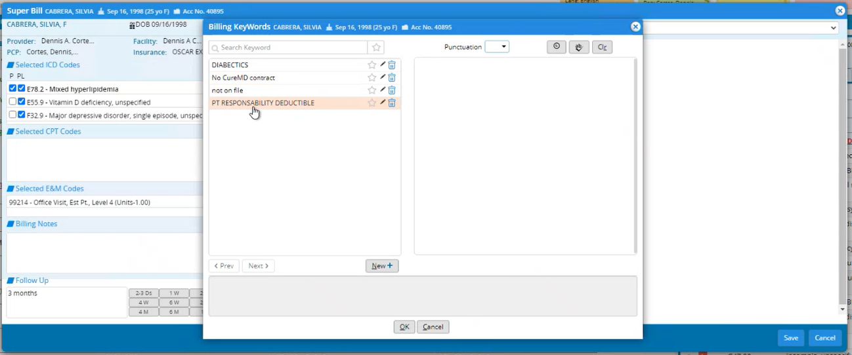

After completing the superbill, the user can save it

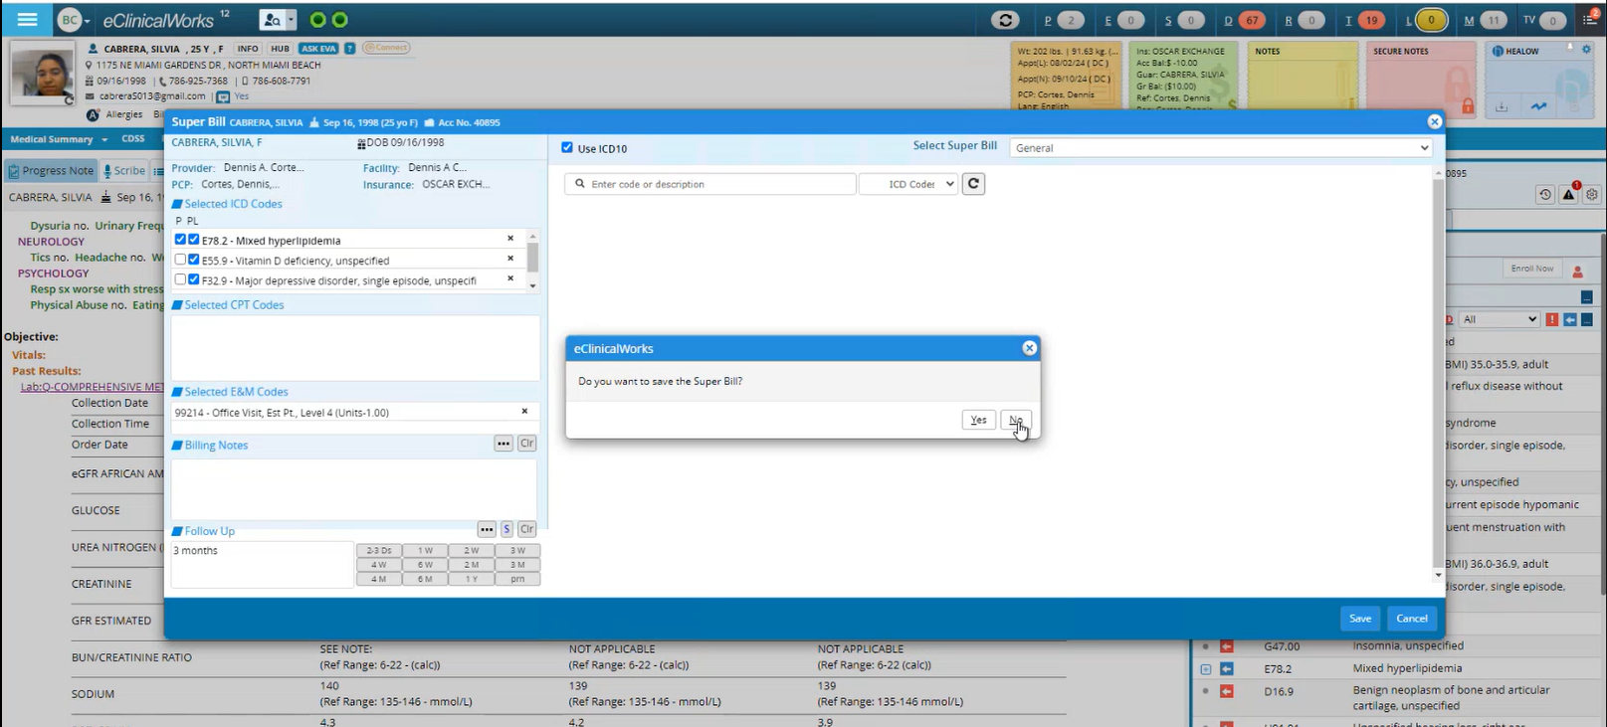

The eSuperBill is complete!

## View Super Bill

The Superbills can be viewed from the Claims Listing page. For this, set the claim Status: “Encounter Without Claims”

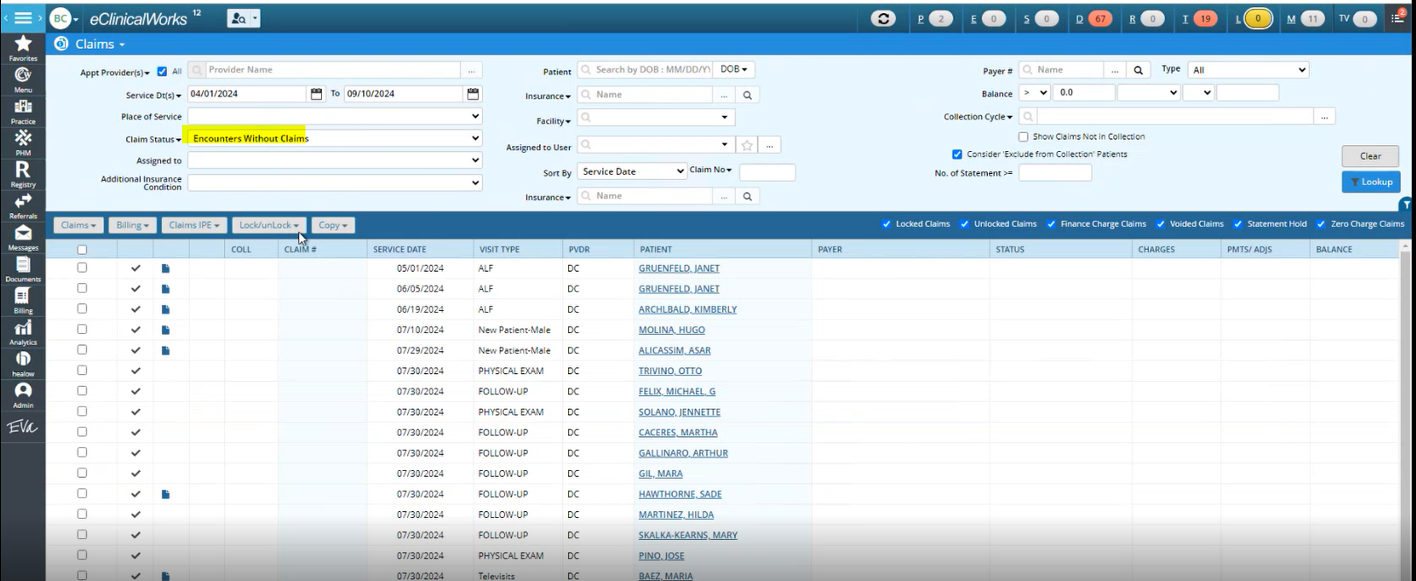

There is an option to view lock/unlocked Encounters.

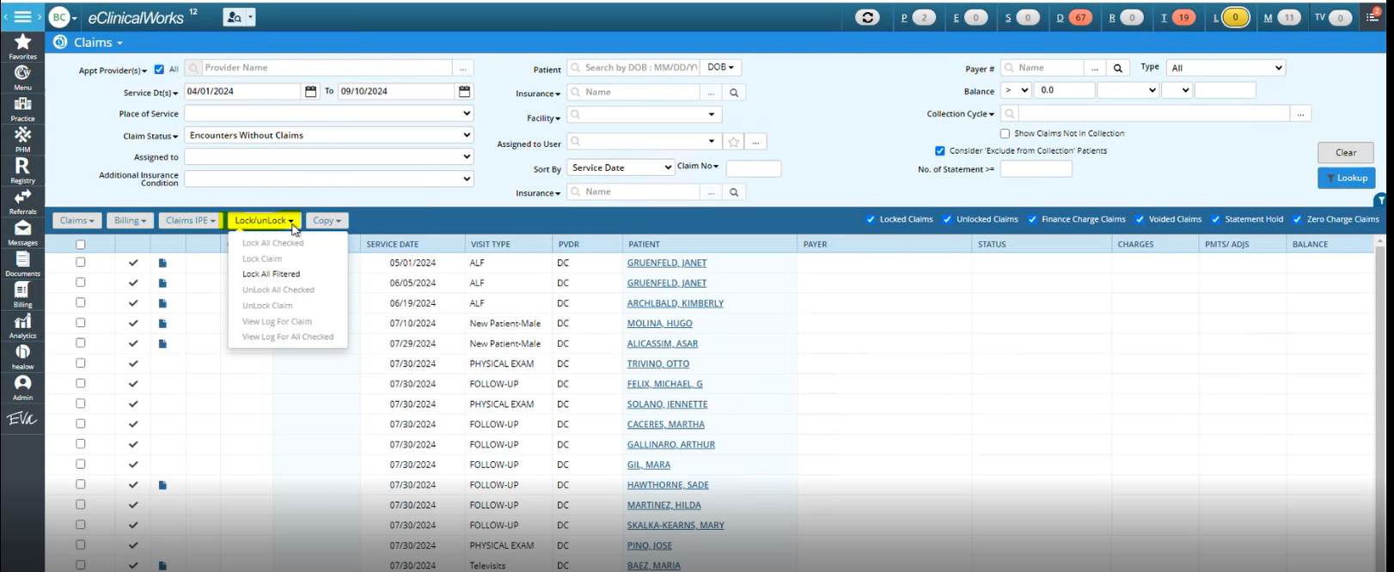

The locked encounter have a pad-lock to differentiate it.   
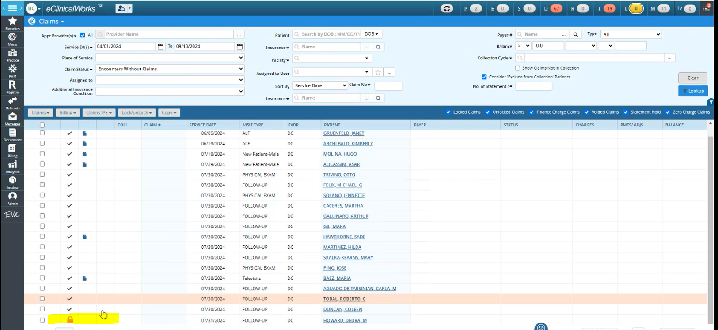

## Comparison with CureMD

|  |  |  |
| --- | --- | --- |
| Feature | eCW Super Bill | CureMD Superbill |
| ICD Code Management | Auto-populated from Progress Note, searchable, quick access to frequently used codes | Auto-populated from Progress Note. Manual entry of ICD-10 codes |
| CPT Code Management | Auto-populated from Progress Note, can be adjusted | Auto-populated from Progress Note, can be adjusted. Manual entry with options for modifiers and quantities |
| E&M Code Selection | Predefined selection, auto-suggested based on the visit | Users select codes manually+ auto , with guidance on E&M calculation |
| Billing Notes | Section for adding notes, with a button | Comments section available for detailed documentation |
| Follow up notes | Section for adding notes | N/A |
| Follow-Up Section | Integrated follow-up scheduling (e.g., 3 months) | No dedicated follow-up section |
| Modifiers & Quantities | Not applicable | Not clear |
| Frequent Code Access | Quick access via a three-dot menu for commonly used codes | Yes |
| Ease of Use | Streamlined for quick entry, minimal manual interaction | Requires more manual input, detailed and comprehensive |
| Tools for Guidance | Focused on direct data entry without additional guidance | Tools to guide E&M code calculation |
|  |  |  |

# **Greenway**

## Summary

The workflow begins with compiling the Progress Note in the Intergy EHR system, where the user can edit or add Evaluation & Management (E&M) codes. Once completed, the Progress Note is saved, and the billing information is auto-reflected in the Intergy Practice Management (PM) system as a "Pending Charges." This Pending charge is similar to superbill.

From the pending charges listing page, user selects a pending charge, and posts it.

## Create Pending Charge/ Superbill

The workflow starts from compiling Progress Note. The Progress Notes are a part of the Intergy EHR system.

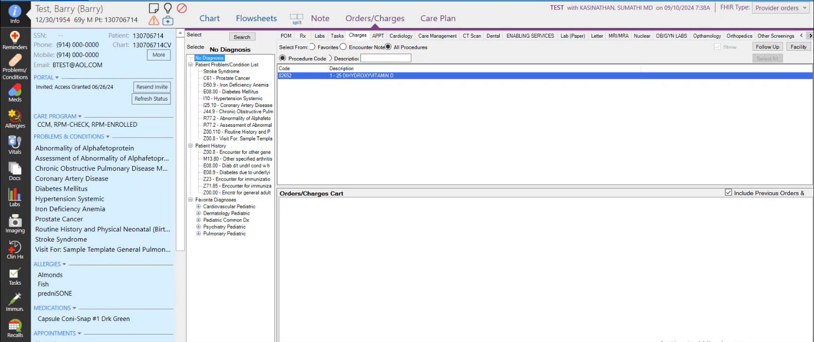

The user can Edit/ add E&Ms from the Progress Note. There are levels of code to choose from, as shown below:

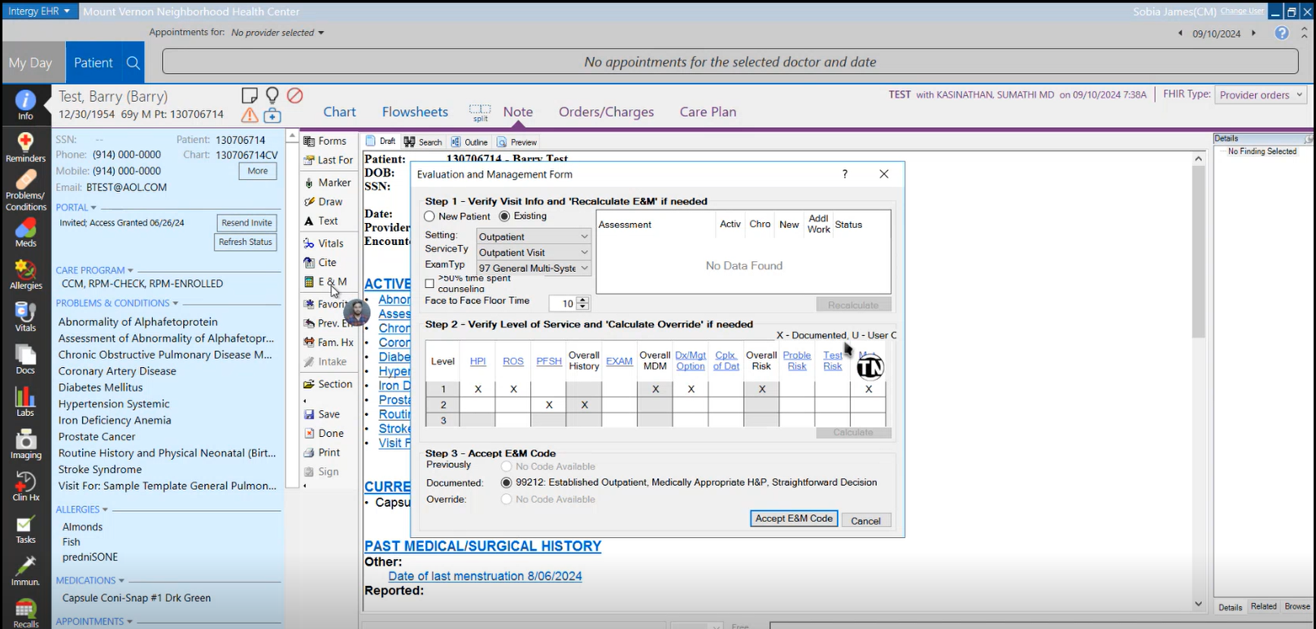

The completed Progress Note is saved in the EHR. The billing info reflects in the Intergy PM system as a “Pending Charges”

Workflow to Pending Charges:

Financial>> Charges>> Pending Charges

The pending charges can be filtered on multiple basis through radio buttons, as shown below:

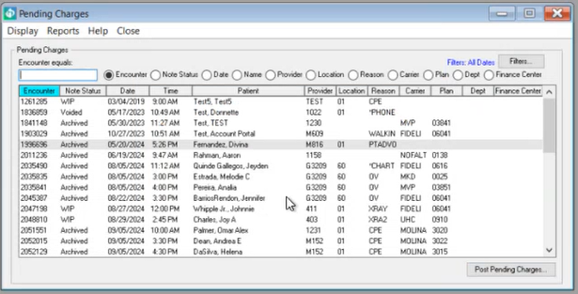

When the User selects a pending charge, and hits “Post Pending Charges” button, a pop-up opens. Here the user Selects the Encounter.

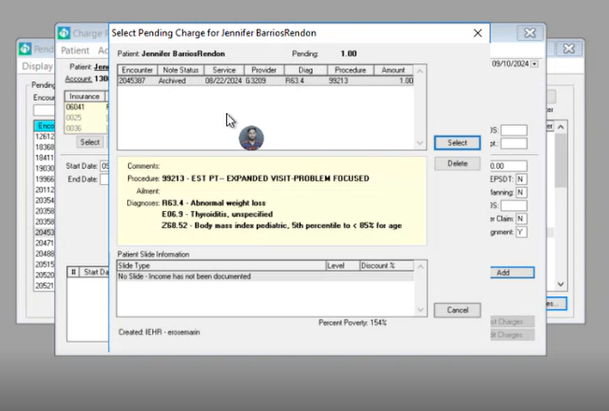

Then, the user selects journal and clicks “Add”.

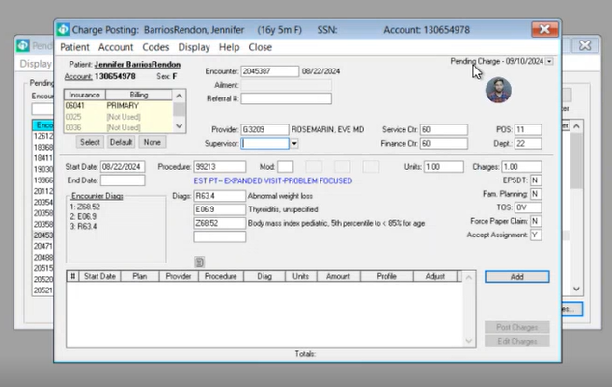

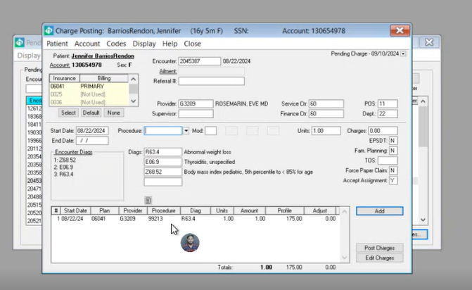

Once added, the user clicks “Post Charges” to post them.

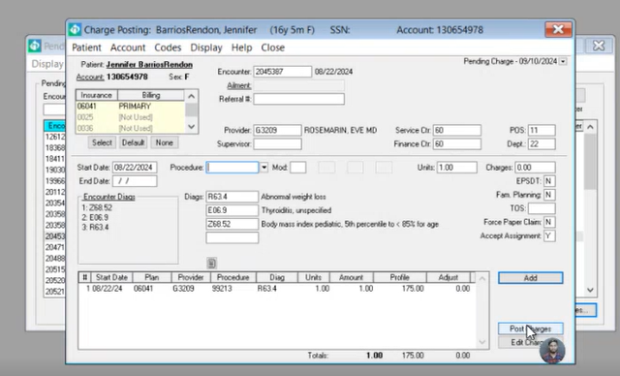

If there are more CPTS, the pop-up opens again.

View Posted Charges   
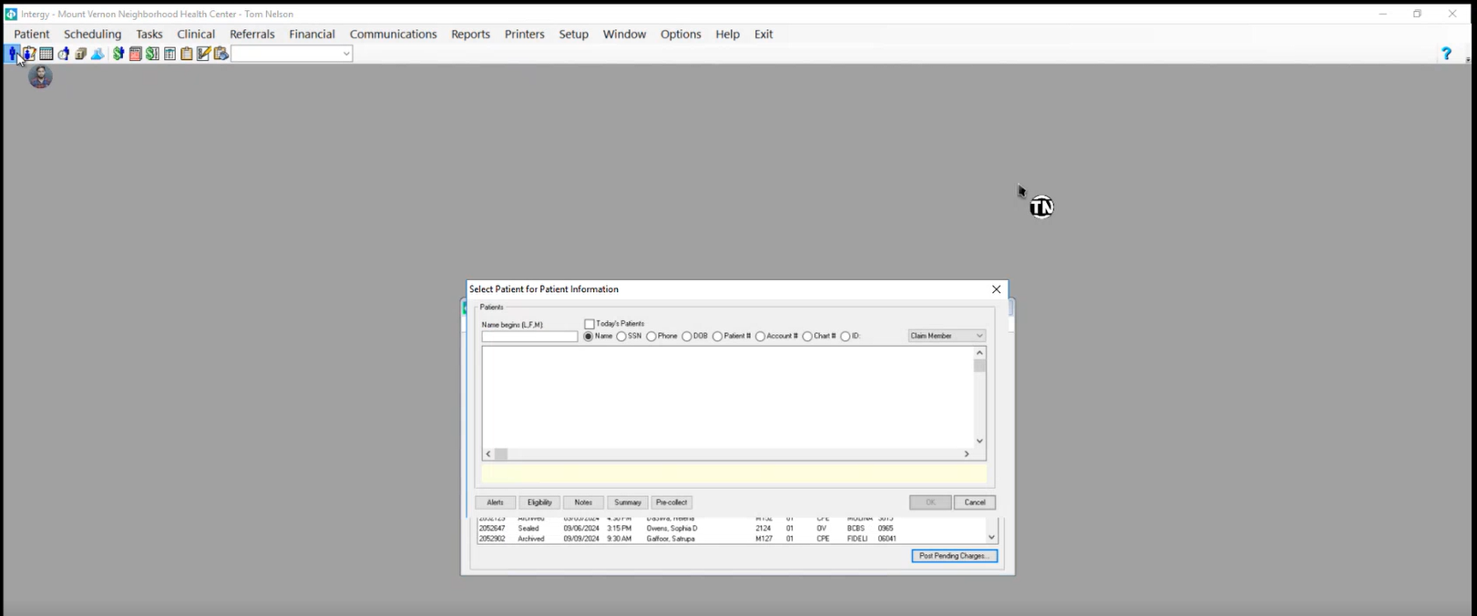

Search   
